Weekly Agenda 10/25 – 10/28
Brit Lit and Comp – McBride
Tues. 25
- QW – Essential question
- Collect Because I Said I Would Card.
- Intro to Tests and The Supreme Ordeal (J. Campbell’s The Monomyth – Review)
  - Learning Goals, expectations, Review EQs
- PRIMING! A new tradtion to get our bodies’ and minds’ ready!
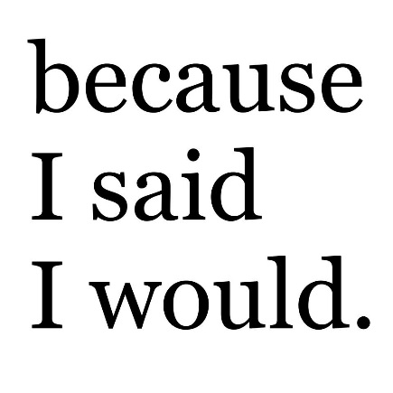
- Get Lit Books for Antigone – Read Intro/Background
- HW – Read pg. 489-493 in new book “Sophocles and His Theater”
Wed 26
- QW – Review Background (Reading Check)
- Begin reading Antigone
  - Role of the Chorus – Review (structural purpose 12. 5)
- HW – Finish Scene 1 (through pg. 503)
Thurs. 27
- Review Scene 1
- Cont. Reading Antigone through scene 3
- HW – Finish Scene 3 (through pg. 516)
Fri 28
- ½ Period Read Antigone (Scene 4)
- ½ Independent reading
- HW – Finish Reading Antigone (scene 5) by Tuesday Nov. 1 (find an online PDF)!
  - Antigone Test Tues. Nov. 1!
Learning Goals:
- Analyze how an author's choices concerning how to structure specific parts of a text (e.g., the choice of where to begin or end a story, the choice to provide a comedic or tragic resolution) contribute to its overall structure and meaning as well as its aesthetic impact.
- Cite strong and thorough textual evidence to support analysis of what the text says explicitly as well as inferences drawn from the text, including determining where the text leaves matters uncertain.

Weekly Agenda 10/25 – 10/28
Brit Lit and Comp – McBride
Tues. 25
- QW – Essential question
- Collect Because I Said I Would Card.
- Intro to Tests and The Supreme Ordeal (J. Campbell’s The Monomyth – Review)
  - Learning Goals, expectations, Review EQs
- PRIMING! A new tradtion to get our bodies’ and minds’ ready!
- Get Lit Books for Antigone – Read Intro/Background
- HW – Read pg. 489-493 in new book “Sophocles and His Theater”
Wed 26
- QW – Review Background (Reading Check)
- Begin reading Antigone
  - Role of the Chorus – Review (structural purpose 12. 5)
- HW – Finish Scene 1 (through pg. 503)
Thurs. 27
- Review Scene 1
- Cont. Reading Antigone through scene 3
- HW – Finish Scene 3 (through pg. 516)
Fri 28
- ½ Period Read Antigone (Scene 4)
- ½ Independent reading
- HW – Finish Reading Antigone (scene 5) by Tuesday Nov. 1 (find an online PDF)!
  - Antigone Test Tues. Nov. 1!
Learning Goals:
- Analyze how an author's choices concerning how to structure specific parts of a text (e.g., the choice of where to begin or end a story, the choice to provide a comedic or tragic resolution) contribute to its overall structure and meaning as well as its aesthetic impact.
- Cite strong and thorough textual evidence to support analysis of what the text says explicitly as well as inferences drawn from the text, including determining where the text leaves matters uncertain.

